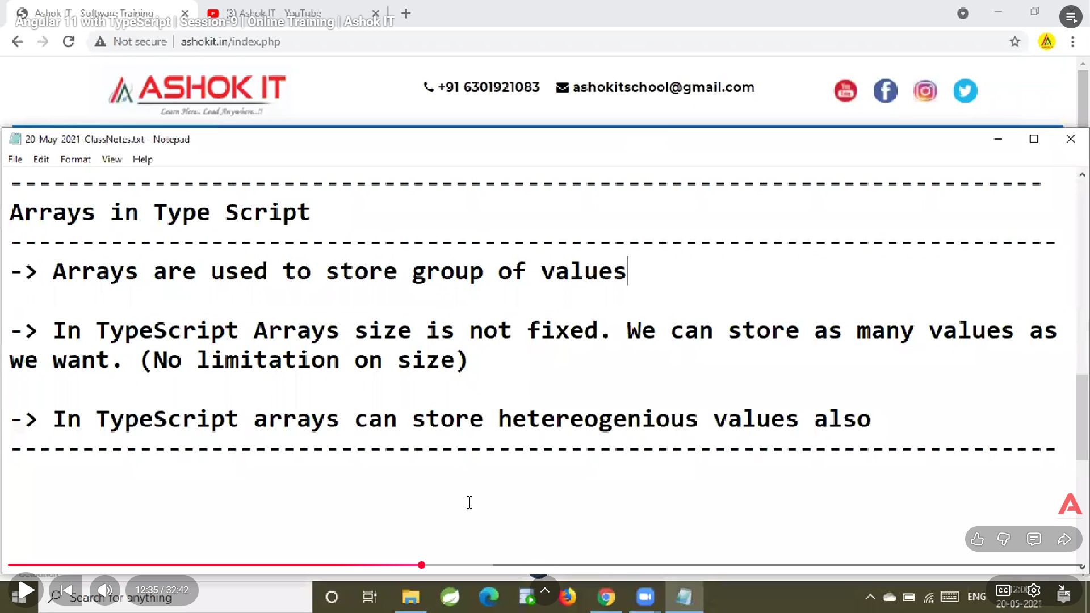

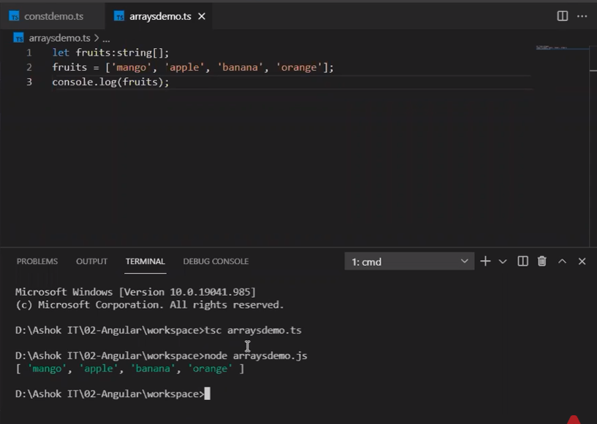
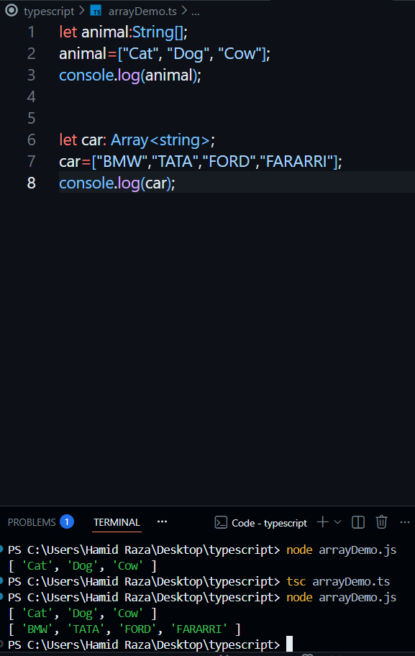
let person:Array<string|number>;
person=["Aman",1,"Bob",2,"Chaman",3,"Dogash",5];
console.log(person);
output:-
[ 'Aman', 1, 'Bob', 2, 'Chaman', 3, 'Dogash', 5 ]
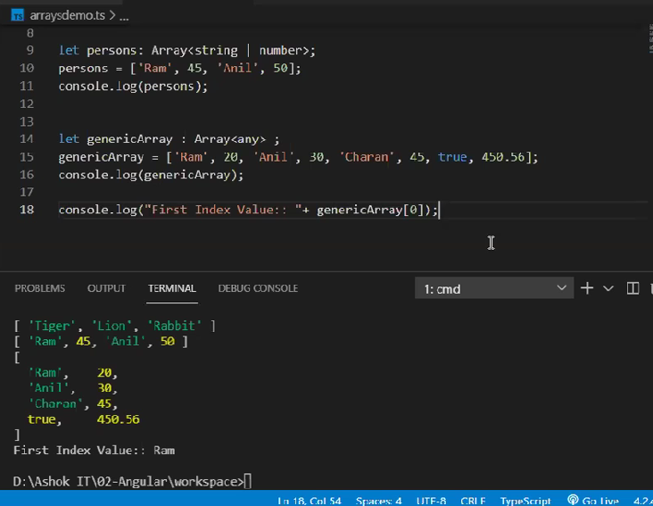
Here is the simplest, clearest, never-forget explanation of Arrays in TypeScript — with examples, diagrams, and interview-friendly concepts.

✅ Arrays in TypeScript — Full Explanation
An array is a collection of elements stored in a single variable.
In TypeScript, arrays are typed — meaning you can define what type of values the array will hold.

1️⃣ How to Declare an Array (2 ways)
1. Using square bracket syntax
let numbers: number[] = [1, 2, 3, 4];
2. Using generic Array type
let numbers: Array<number> = [1, 2, 3, 4];
Both mean the same thing.

2️⃣ Why Arrays in TypeScript are Different from JavaScript?
JavaScript arrays can hold any type (no restrictions):
let arr = [1, "hello", true];
TypeScript arrays are type-safe:
let arr: number[] = [1, "hello"]; // ❌ Error

3️⃣ Types of Arrays
✔ 1. Number Array
let nums: number[] = [10, 20, 30];
✔ 2. String Array
let names: string[] = ["Hamid", "Raza"];
✔ 3. Boolean Array
let flags: boolean[] = [true, false, true];
✔ 4. Any Array
Allows mixed values:
let mix: any[] = [10, "hello", true];
✔ 5. Array of Objects
let users: { id: number; name: string }[] = [
{ id: 1, name: "Hamid" },
{ id: 2, name: "Raza" }
];

4️⃣ Array Methods (Most Important)
✔ push() → add at end
let arr = [1, 2];
arr.push(3);
console.log(arr); // [1, 2, 3]
✔ pop() → remove from end
arr.pop(); // removes 3
✔ unshift() → add at beginning
arr.unshift(0); // [0, 1, 2]
✔ shift() → remove from beginning
arr.shift(); // [1, 2]
✔ map() → transform values (Very useful)
let doubled = [1,2,3].map(x => x * 2);
console.log(doubled); // [2,4,6]
✔ filter() → filter values
let even = [1,2,3,4].filter(n => n % 2 === 0);
console.log(even); // [2,4]
✔ find() → find first matching element
let result = [10, 20, 30].find(x => x === 20);
console.log(result); // 20

5️⃣ Tuple (Special Type of Array)
A tuple is an array with fixed length & fixed types.
let person: [string, number, boolean] = ["Hamid", 25, true];
This is allowed:
✔ "Hamid" is string
✔ 25 is number
✔ true is boolean
But this is not allowed:
person = [25, "Hamid", true]; // ❌ Error (wrong order)

6️⃣ Readonly Arrays
let nums: readonly number[] = [1, 2, 3];
nums.push(4); // ❌ Error (cannot modify)
Used when you want to protect data (e.g., configuration).

7️⃣ Best Practice for Arrays
❌ Avoid any[]
let arr: any[] = []; // not recommended
✔ Use strong typing
let prices: number[] = [];
let usernames: string[] = [];
let products: Product[] = [];

8️⃣ Interview Level Example
Q: What is the difference between number[] and Array<number>?
Answer:
Both are the same.
number[] → shorthand
Array<number> → generic form

9️⃣ Complete Example (All Operations)
let fruits: string[] = ["Apple", "Banana"];

// Add
fruits.push("Mango");

// Remove
fruits.pop();

// Insert at start
fruits.unshift("Guava");

// Remove from start
fruits.shift();

// Map
let upper = fruits.map(f => f.toUpperCase());

// Filter
let longNames = fruits.filter(f => f.length > 5);

console.log(fruits);
console.log(upper);
console.log(longNames);

🔟 Diagram (Easy to Remember)
Index → 0 1 2
Value → "Apple", "Banana", "Mango"

Array = Ordered List + Same Type

🎯 Summary — Never Forget
Concept | Meaning
number[] | array of numbers
string[] | array of strings
any[] | mixed values (not good)
Tuple | fixed type + fixed length
Readonly array | cannot be changed
map() | convert values
filter() | keep matching values
find() | first matching value

If you want next:
✅ Objects in TypeScript
✅ Functions in TypeScript
✅ Interfaces & Types
✅ OOP in TypeScript
Just tell me “Explain objects” or whatever you want next.

